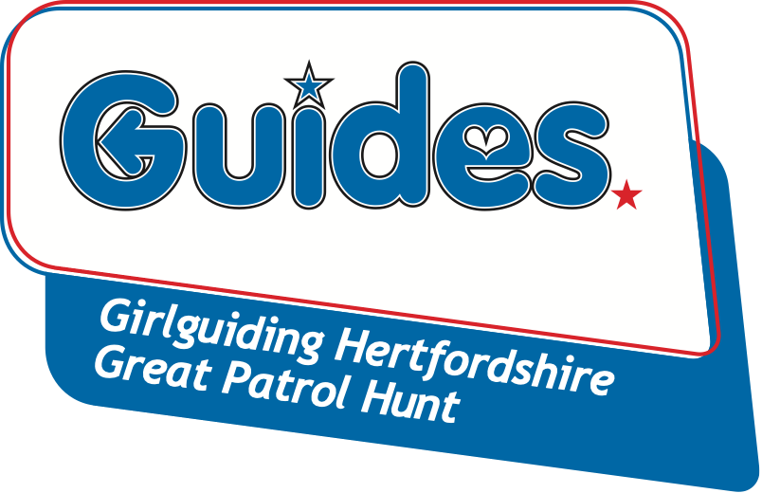

Thank you for completing your Great Patrol Hunt entry to attend the annual competition to find the ‘Greatest Patrol’ in Hertfordshire. We want to make the entry process as easy as possible. You will also need to complete a separate Information & Consent form & Health for each individual attending, this may be downloaded from the Girlguiding Hertfordshire website .
Please note:
- Places will be allocated on a ‘first come, first served’ basis. Patrols must consist of 4-6 Guides, and should not include more than 10 different members throughout the three rounds.
- Members must be 10-15 years old and a member of a Guide Unit for each round they compete in.
- Teams need not be regular weekly Patrols, but they must choose a unique name for themselves in order to enter.
Great Patrol Hunt - Round 1
Saturday 16th October 2021
at Borehamwood Youth FC, 82 Aycliffe Road, Borehamwood WD6 4JW
- To be eligible for Round 3, a patrol and at least two of its participants must have competed in one of the previous rounds.

PATROL NAME: |  | UNIT NAME:
 | Participants Full Name | Your GG Registration No.  (ask your Leader) | £  (£5 per head)
PL
2
3
4
5
6
 |  | TOTAL | £

To be completed by your unit Guide Leader only (where appropriate please PRINT)
LEADER’S NAME:
LEADER’S SIGNATURE OF CONSENT:
LEADER’S EMAIL ADDRESS:
TELEPHONE:

Cheques are made payable to ‘Herts Guides GPH’. Please post your completed Entry Form, payment and an Information & Consent form for each competitor to Jean Banks, 2 Rucklers Lane, Kings Langley WD4 8AU before the closing date Friday 1st October 2021 (LATE ENTRIES WILL NOT BE ACCEPTED). On acceptance of your entry, patrol instructions are emailed to the Leader after the closing date. All patrols should make a unique patrol badge that clearly displays their patrol name and the patrol member’s name. Competitors must wear their guide uniform top with their badge clearly displayed.

