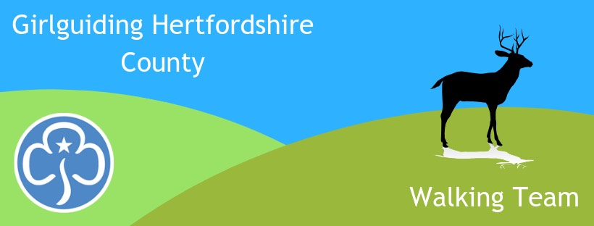
Girlguiding Hertfordshire
Follow us on Facebook for walking activities
www.facebook.com/hertsguideswalkingteam

Walking Team
Newsletter Dec 2021

As we enter another period of uncertainty about Covid, whatever has to be cancelled, one thing seems certain; we will almost cetainly still be able to go on outdoor walks! So check out the events list below, many in new areas. There’s something for all sections.

Also, it’s not too late to finish the Marathon Challenge … or even to start it! We have plenty of badges in stock so if you’d like to do it yourself and /or encourage your girls to do the challenge over the Chriastmas holidays, rest assured you’ll still get badges. Just walk, run or use a wheelchair to complete 42km over as many sessions as it takes. 2-3km a day soon adds up. You can carry on if you wish and earn the next 4 badges to make up the 5 Olympic rings. Check the website for details:
https://www.girlguidinghertfordshire.org.uk/get-involved/challenge-badges/#marathon

Enjoy your walking and best wishes for the festive season,
Alison Tuch, County Walking Adviser

Walking Events email walking@girlguidinghertfordshire.org.uk to book
4-5th December – Level 1 Walking Scheme course and Water Safety Module. Only £20 including overnight accommodation and food at Ellesborough Guide Centre. For anyone wanting more confidence to take girls out locally or in other lowland situations. Subsidised by National HQ.
Sunday 12th December – Adult Social Walk from Wheathampstead to Batford Springs plus optional Christmas meal at The Miller & Carter –5.8mi or 9km, 3 hour guided walk, no charge. Lunch at own expense, limited places, must be pre-booked.
Sunday 16th January 10am – 12.15pm – Social Walk from Preston, nr Hitchin. Approx 5 mi or 8km. For adults, Young Leaders & Rangers. Just ‘walk & talk’ or improve your map reading skills if you wish – please say if you want this when booking. No charge.
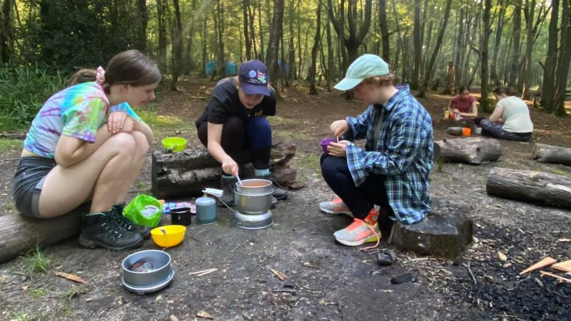
29-30 January – Bronze/Silver DofE Training at Cherry Green Trees, London Colney. £50 to cover accommodation & food. Contact Katie Wright dofe@girlguidinghertfordshire.org.uk for more information.
Sunday 6th February – Social Walk from Debden Green, nr Saffron Walden. Approx 10.30-12.30. For adults, Young Leaders & Rangers. Just ‘walk & talk’ or improve your map reading skills if you wish – please say if you want this when booking. No charge.
4-5 March – 16 hour Outdoor First Aid course. For those needing a 16 hour first aid qualification in conjunction with other outdoor leadership qualifications eg walking, DofE, climbing, cycling. Also useful for anyone wanting to learn a bit more than First Response. Base will be at Little Gaddesden (W Herts), but much of the course will be taught outside and all scenarios will be in Open Country. Course fee £130 but this can be met by county for those using the qualification in Girlguiding.
Saturday 5th March – Social Walk in Lea Valley, around the Sculpture Trail. Approx 2-4pm. For adults, Young Leaders & Rangers. Just ‘walk & talk’ or improve your map reading skills if you wish – please say if you want this when booking. No charge.
18-20 March – Adult Social Walking Weekend. Venue tbc, probably in the Black Mountains. Low cost, bunkhouse style accommodation, shared transport. More information after Christmas, when we know more about government and Girlguiding Covid regulations.
1-3 April DofE Expedition Weekend in the Chilterns. £30. Contact Katie Wright dofe@girlguidinghertfordshire.org.uk for more information. Note there are several other possible expedition dates so contact Katie if interested.
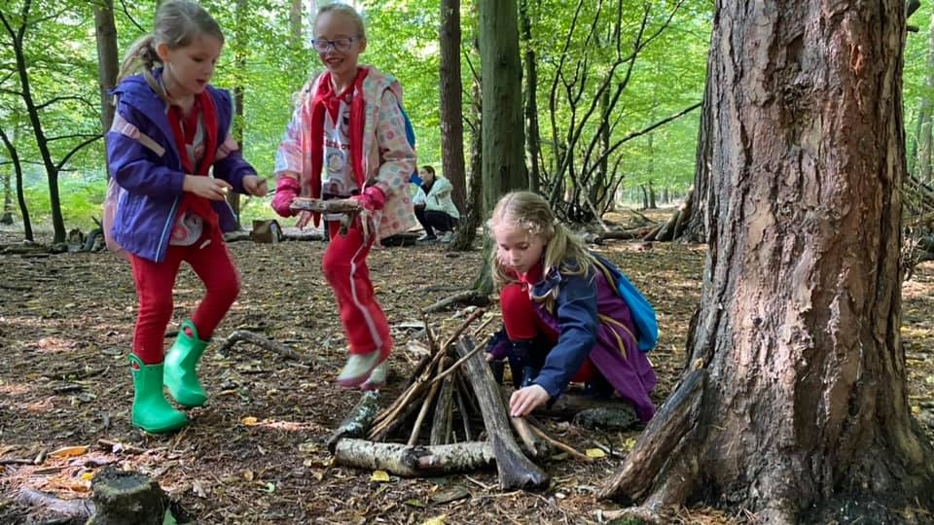
Saturday 23rd April - Sensory Safari for Rainbows & Brownies and Explore 3 for older Brownies & Guides. Both walking team activites to be included in the County Outdoor Day. More information to follow but we are excited to be re-running the Sensory Safari that we organised in October where the sun shone and the girls loved building tiny fairy houses and bigger dens for themselves as well as using all their senses; listening to stories, smelling & tasting herbs, feeling bark etc. The Explore 3 activities will enable girls to earn that skills builder.
29th April – 2nd May - Introduction to the Hills. A camping weekend for Herts Guides and Scouts, aged 11 - 13, at The Foundry Adventure Centre in the Peak District. Activities include hill walking, outdoor climbing, cycling and caving. Cost: £140 (includes food and transport). Guides can attend without their leaders. email itthherts@gmail.com for further information and an application form.

Sunday 8th May – Social walk details tbc
10-12 June - Anglia Region Adult Social Walking Weekend in Shropshire – low cost, shared transport. Register your interest with Verity MacLachlan walking@girlguiding-anglia.org.uk
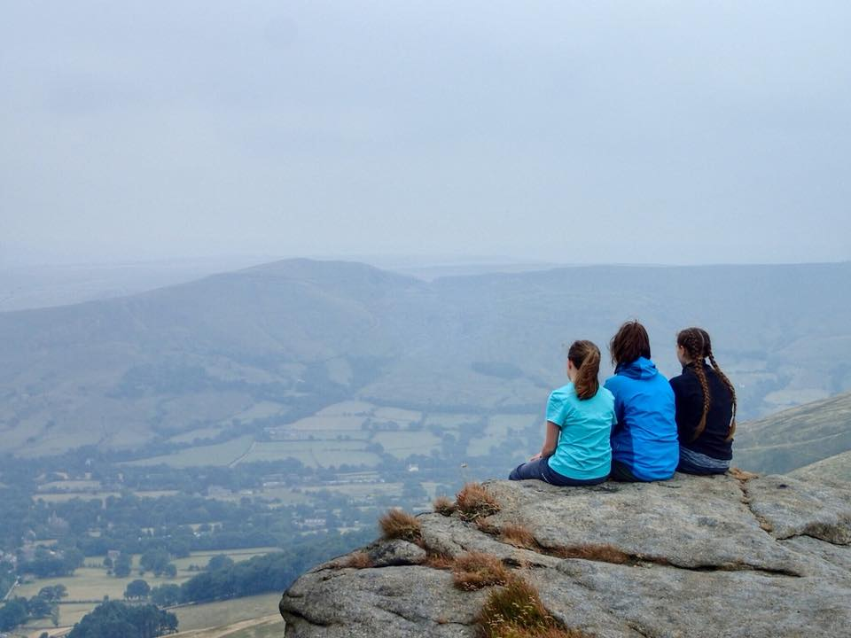
Saturday 18th June pm – Social walk details tbc
8-10 July - Mountain Experience, at Glenbrook Guide Centre, Peak District. A hillwalking weekend for Rangers & Young Leaders wanting to learn map reading & navigation skills for their own adventures, for DofE, or so that they can enter the Hertfordshire Scouts Peak Assault competition in remote terrain. £70 to include transport, warm indoor bunk bed accommodation and food.
26-31 Aug - Anglia Heads High. A hill/mountain weekend in Crainlarich, Scotland for adults. £17/night or £75 for 5 nights. Option to self-cater or pay £10 per day. Own travel. Email Moira Ledbetter moiledie@yahoo.co.uk for more information / to book.

