SOCIAL WALKING WEEKEND
10 -12 June 2022
New to Hillwalking to Level 2

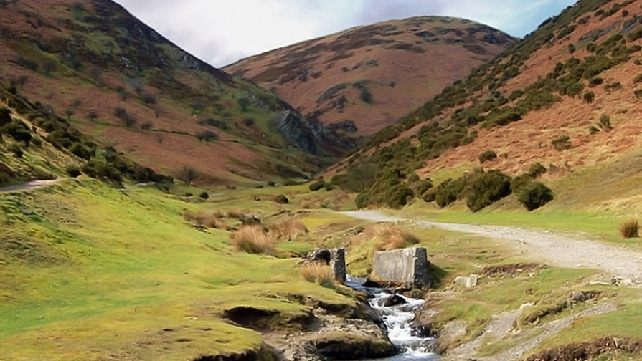
Join us to enjoy the lovely hills of Long Mynd area or Wenlock Edge Shropshire for:
Level 2 Walking scheme logbook walks. Practice navigation and other skills with experienced hillwalkers on hand to assist if wished.
Level 1 Also for those new to hillwalking
Primarily for Leaders and Adults.
Rangers with permit or their leaders welcome to camp and use hostel for meals and evenings and join led walks.
Dates: Friday,10 to Sunday,12 2022.
Extra nights bookable separately.

Location: Shropshire. Bridges Long Mynd Youth Hostel, Ratlinghope, Shropshire, SY5 0SP
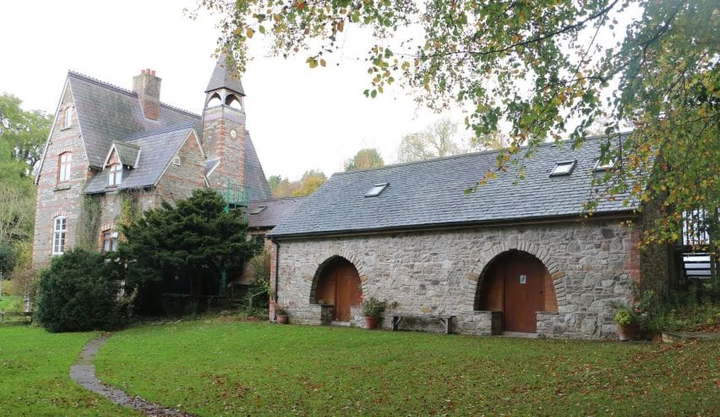
Cost: TBC. Accommodation £45 for 2 nights . 14 (+2) places reserved
Sleeps 36 in total
OR
Camp at Brow Farm near by for £7 a night or pods available

Catering: £10 for weekend (or self-catering). Saturday night meal at the Pub or order dinner at the Hostel. Pub is normally very popular so will need to book in advance.
The pub also has rooms to let, other B&Bs nearby.
Enquiries to Verity Maclachlan Region Walking Advisor walking@girlguiding-anglia.org.uk
Book via Anglia https://www.girlguiding-anglia.org.uk/events

