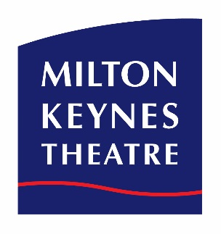
INFORMATION

Are you a Uniformed Group leader?
Why bring your pack on an organised group outing to Milton Keynes Theatre’s pantomime?

Here are the benefits!
Great discounts for 10 or more.
1 free leader ticket for every 10 paid.
Free ice cream with every paid ticket.
Enjoy the benefit of reserving tickets with set pay by dates, allowing plenty of time to sell tickets and collect monies before payment is due. We don’t ask for deposits and bookings can be amended up or down at any time before payment is made so there is no financial risk to your organisation.

And of course most importantly it’s a fun night out!

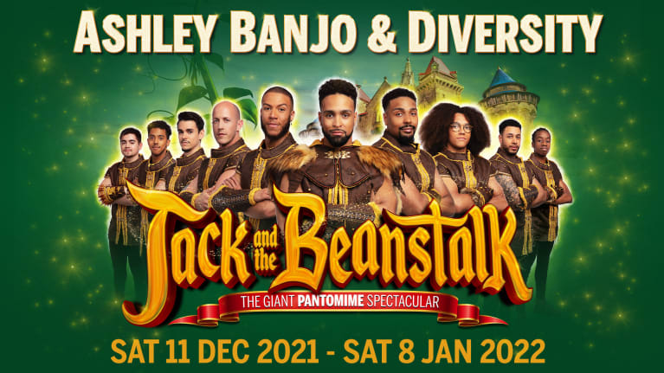

Starring Britain’s Got Talent winners, street dance sensations Ashley Banjo & Diversity,
Jack and the Beanstalk will be a GIANT adventure for all the family!
Follow Jack and climb a beanstalk of gigantic proportions to cloudland in this spectacular family pantomime. Doomed to sell his trusty cow, join Jack as he fights to save the beautiful Princess, outwit the evil giant and win riches beyond his wildest dreams, and the hand of the girl he loves.
Expect laughs, music, special effects, magic beans and bundles of audience participation in this giant of a pantomime!

At the following performances, MKT is pleased to offer a special price for
Uniformed Groups of 10 or more.
14, 15, 16 Dec at 7pm and 18 Dec 11am, Bands P, A – D seats in Stalls/Circle £15 each,
14, 15, 16 Dec at 7pm, Bands B – D seats in Upper Circle £12 each,
Plus 1 free leader for every 10 paid and a free ice cream for every paid ticket!

5, 6, 7, 8 Jan at 7pm, Bands P, A – D seats in Stalls/Circle £13 each,
5, 6, 7, 8 Jan at 7pm, Bands B – D seats in Upper Circle £11 each
Plus 1 free leader for every 10 paid and a free ice cream for every paid ticket!
To make your reservation email groupsales@atgtickets.com or call 020 7 206 1174 (local rate call)

Uniformed Groups include Rainbows Brownies, Guides, Beavers, Cubs, Scouts, Girls + Boys Brigades and Cadets. We ask if possible that your group attends in Uniform. These discounts are to be used for a minimum group size of 10 qualifying young people plus 1 leader. All discounts subject to availability and prices subject to change.
Please check the Health & Safety requirements before your visit.
ATGTICKETS.COM/MiltonKeynes
Find out what we need you to bring to show your COVID-19 Status Certification.

