INFORMATION

Are you a pack leader? Are you involved with any of our qualifying Uniformed Groups?
Would you like to bring your Uniformed group on an organised outing to the theatre?

Dial M For Murder
Tue 26 – Sat 30 Oct 2021

TV and Stage favourite, Tom Chambers, (Top Hat, Strictly) stars as the charismatic and manipulative Tony Wendice, a jaded ex-tennis pro who has given it all up for his wife Margot played by Diana Vickers (West End star, No.1 chart – topping recording artist and The X Factor finalist) When he discovers she has been unfaithful his mind turns to revenge and the pursuit of the ‘perfect crime.’

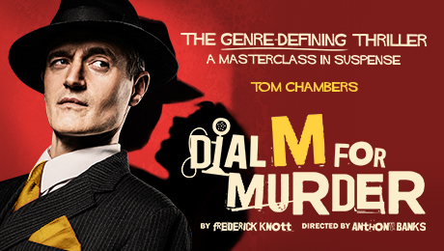

At the following performances, MKT is pleased to offer a special price for
Uniformed Groups of 10 or more
Tue – Thu 7.30pm, Wed 2.30pm seats in Bands B/C £12.50 each
plus 1 free leader for every 10 paid

To make your reservation for any of the above shows email melaniegillies@theambassadors.com or nicolajelliman@theambassadors.com and quote Uniformed Groups.

Uniformed Groups include Rainbows Brownies, Guides, Beavers, Cubs, Scouts, Girls + Boys Brigades and Cadets. These discounts are to be used for a minimum group size of 10 qualifying young people plus 1 leader. All discounts subject to availability and prices subject to change.
Please check the Health & Safety requirements before your visit.
ATGTICKETS.COM/MiltonKeynes
Find out what we need you to bring to show your COVID-19 Status Certification.

