London bridges ‘10 bridges over 10km’ treasure hunt
Booking form – Sunday 21 September 2025
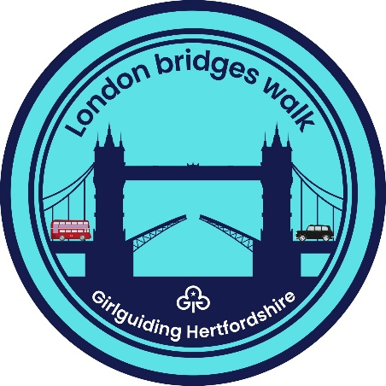
On Sunday 21 September 2025, our group plans to attend this event in London

Unit name: _________________________ District: ___________________

Section: Brownies | Guides | Rangers | adult group

Unit leaders name: _______________________Telephone: _________________

Email: ______________________________________

Emergency home contact’s name: __________________________________
Email: ________________________________________

Telephone: ____________________________________

Number of participants: ___________ ___@£2 each

BACS payment to:
Account name: Girlguiding Hertfordshire
Sort code 40-52-40
Account number 00013524
Ref “WTLB unit name”

I have sent a BACS payment ref “___________________” totalling £ ___________

Please tell us if anyone in your group has any special requirement/s (e.g. health matters and mobility).

Please forward the completed form to walking@girlguidinghertfordshire.co.uk by Friday 1 August 2025 at the latest.

