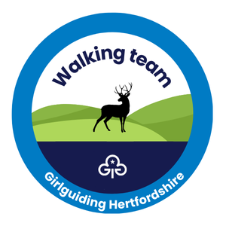
Chalk Stream challenge badge event booking form
Sunday 8 June 2025

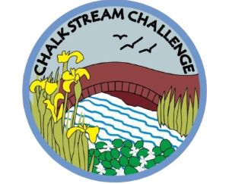
Bring your Rainbows, Brownies or Guides to complete their Chalk Stream challenge badge along the lovely River Chess with the Herts walking team on Sunday 8 June.
An easy walking 4k circular walking route on good paths through meadow, woodland, and along the chalk stream.
Girls will complete multiple activities at points along the way which will include river dipping with a local expert from the Chiltern Chalk Stream Project.
The day will start and finish (registration) at Chesham Moor car park, Moor Road, Chesham HP5 1SE. GR SP963008. Although there is free parking car sharing is strongly requested.
Starting times will be staggered from 10am-1pm and the event will take around 2.5 -3 hours to complete.
To book your place, please complete this form and return it to the walking team at walking@girlguidinghertfordshire.org.uk with the subject ‘Chalk Stream’.
At least 1 leader from each unit must attend with their girls, additional ‘ratio adults’ can be parent helpers. The usual Girlguiding outdoor ratios apply 1:5 Rainbows, 1:8 Brownies and 1:12 Guides.
Information and consent forms (attached) will be required for this activity and units will need to arrange their own home emergency contact.
Payment of £5 per girl is required on booking and includes all activities and an event badge.
BACS payment to: Girlguiding Hertfordshire sort code 40-52-40 account number 00013524 ref “CSCB Unit Name”.
Final leader information will be emailed 2 weeks prior to the event.

Page 1 of 2
Booking Form: Chalk Stream challenge badge event

On Sunday 8 June 2025, our group plans to attend this event in Chesham

We would prefer an earlier/later start time if possible*
We intend to travel by either car share/ minibus*

Unit name: ________________________________________District: ____________________
Section: Rainbows | Brownies | Guides *

Unit leaders name: _______________________________Telephone: ____________________

Email: __________________________________________________________________

Emergency home contact’s name: _____________________________________________
Email: ____________________________________________________________________

Telephone: ____________________________________________________________________

Number of girls attending and payment details: __________ Members @ £5 each

Number of leaders attending (£ free) ______ Total amount due £ _____________

I have sent a BACS payment ref “________________________________________”
A separate Information and consent form is attached and must be completed for all members under 18 attending. Leaders are responsible for their own unit’s permission forms and should bring them to the event. Please tell us if anyone in your group has any special requirement/s (e.g. health matters and mobility).
Please forward the completed form to walking@girlguidinghertfordshire.co.uk by Friday 18 May 2025 latest and make payment to the county bank account (details on page one).
*Delete as applicable
Page 2 of 2

