Anglia heads High
Above and beyond level 2

Join us for a social walking adventure in the Scottish highlands, a chance to go beyond level 2, bag a Munro
and catch up with friends, or make some new ones.

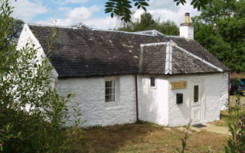
Date : Friday 26th August – Wednesday 31st August 2022
Cost : £75 for 5 nights (or £17 per night) –accommodation only (cost reduces on more bookings, bring your friends), £40 deposit (non-refundable), balance 4 weeks before
Location : Crainlarich, Scotland
Accommodation : Inverardran Cottage,Crianlarich,FK20 8QS
"I'd rather be hiking in the rain, than sitting inside at a desk on a sunny day." – Unknown
(Ochil Mountaineering Club Cottage)
Spaces : 18 beds (2 dorms, alpine style bunks)
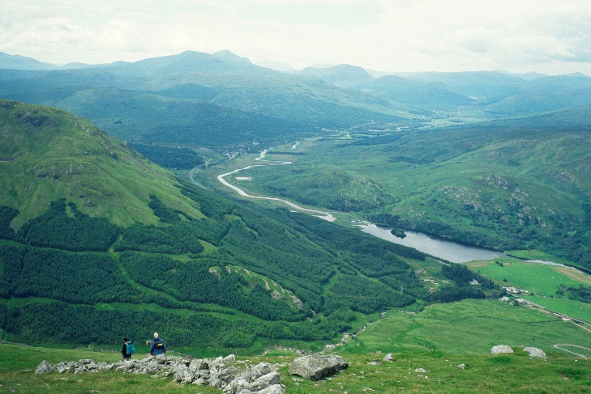
Catering : self-catering or £10 per person per day
Ben More towards Crianlarich credit VisitScotland / Paul Tomkins

Ben A-An credit VisitScotland / Kenny Lam

Enjoy walks either from the door (Cruach Ardrain, Ben More, Stob Binnein, Ben Challum,
Meall Glas, and Sgiath Chuil) or slightly further afield (Arrochar, Crianlarich, Ben Lawers, Tyndrum and Bridge of Orchy hills are with 30 minutes drive)

E-mail – moiledie@yahoo.co.uk to book, or for more details

