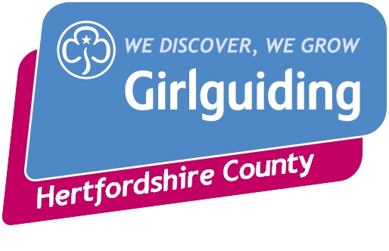
Girlguiding Hertfordshire International Day
For all Sections

Come and join us for an exciting day exploring the 5 WAGGGS regions and take part in activities including drumming, Bollywood dancing, chocolate, crafts and much more.

WHEN: Sunday 23rd October 2022, 10.00am – 4.00pm

WHERE: Townsend Church of England School, High Oaks, St Albans AL3 6DR

COST: £25 per head. (Any profits will go to the Hertfordshire Guide Centre Improvement Fund)

WHO CAN COME? Any Rainbow, Brownie, Guide, Ranger or Young Leader from Hertfordshire. (Leaders need to accompany Rainbows, Brownies and Guides at the appropriate ratio – let us know if you need help and we can match up small groups especially guide age)

CLOSING DATE FOR APPLICATIONS; Friday 30th September 2022.

As there are a limited number of places these will be allocated on a first come, first served basis. So if you want to attend please make your payment by BACS and send the completed attached form to:-

Jean Banks at gghertsoaa@gmail.com

An Information and Consent form for your use is also available to download from the website – please amend this to your own needs. These do not need to be sent in.

Confirmation of places will be sent on receipt of application forms and confirmation that BACS payments have been received. Please note this may take up to two weeks.

Final instructions will be sent by email after the closing date.

Once places have been confirmed refunds will only be made under exceptional circumstances.

If you have any questions please contact:-

Group Leader Administrator
Lorraine England Jean Banks
07535260546 07887781481 (after 6.30pm)
International@girlguidinghertfordshire.uk gghertsoaa@gmail.com

INTERNATIONAL DAY 2022 APPLICATION FORM

UNIT NAME

DISTRICT |  | DIVISION
LEADER’S NAME

LEADER’S CONTACT DETAILS
ADDRESS

TELEPHONE

EMAIL ADDRESS

 | Numbers | Cost per person | Total Cost
Rainbows |  | @£25 per head | £
Brownies |  | @£25 per head | £
Guides |  | @£25 per head | £
Rangers |  | @£25 per head | £
Young Leaders  (Taking part in activities) |  | @£25 per head | £
Adults / YLs* |  | NO COST*
Please pay total by BACS – details below |  | TOTAL | £
I confirm BACS payment has been made. Please enter payment date. |  | Date:-

BACS Details
Account Name: - Girlguiding Hertfordshire
Sort Code:- 40-52-40
Account Number:- 00013524
Reference:- INTD and unit name

Send forms to: Jean Banks at gghertsoaa@gmail.com

* Please note that as there is no charge for Adults and Young Leaders accompanying girls they will not have been allowed for in the numbers and there will not be sufficient materials for them to make anything.

