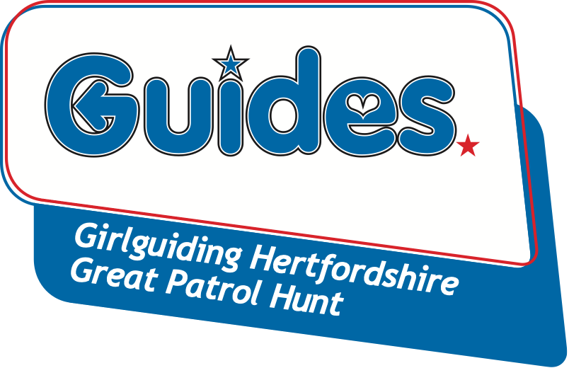

Thank you for your interest in the Great Patrol Hunt annual competition to find the ‘Greatest Patrol’ in Hertfordshire.

We want to make the entry process as easy as possible. Please complete the entry form (see next page) and send it with payment (please note that the cost for Round 3 is £25 per person) to the address below along with a completed separate Information & Consent form and Health form for each individual attending, you can download prepared forms from the GPH page of the Girlguiding Hertfordshire website.

Please note:
- Places will be allocated on a ‘first come, first served’ basis. Patrols must consist of 4-6 Guides, and should not include more than 10 different members throughout the three rounds.
- Members must be 10-15 years old and be a member of a Guide Unit for each round they compete in.
- Teams need not be regular weekly Patrols, but they must choose a unique name for themselves in order to enter.
Great Patrol Hunt - Round 3
Friday 24th – Sunday 26th June 2022
Wymondley Woods Scout and Guide Centre,
Wymondley Road, Willian, SG6 2UB
- To be eligible for Round 3, a patrol and at least two of its participants must have competed in one of the previous rounds.

Cheques are made payable to ‘Herts Guides GPH’. Please post your completed Entry Form, payment and an Information & Consent form and Health form for each competitor to Jean Banks, 2 Rucklers Lane, Kings Langley WD4 8AU before the closing date Friday 27th May 2022 (LATE ENTRIES WILL NOT BE ACCEPTED).

Please note that Round 3 is a camping round and accommodation is in tents.

On acceptance of your entry, patrol instructions are emailed to the Unit Leader after the closing date.

All patrols should make a unique patrol badge that clearly displays their patrol name and the patrol member’s name.

Competitors must wear their guide uniform top with their badge clearly displayed.

Details of kit required for individuals is shown on the Information and Consent form but we would ask units to provide a tent (or tents) which will accommodate the girls from your unit.

Please complete the information below and return this form with Information & Consent Forms and Health forms for each participant.
Entries should be returned to Jean Banks, 2 Rucklers Lane, Kings Langley WD4 8AU before the closing date Friday 27th May 2022 (LATE ENTRIES WILL NOT BE ACCEPTED).
PATROL NAME: |  | UNIT NAME: |  |  | Please indicate if participant took part in
 | Participants Full Name | Your GG Registration No.  (ask your Leader) |  | £  (£25 per head) | Round One  Yes / No | Round Two  Yes / No
PL
2
3
4
5
6
 |  | TOTAL |  | £
To be completed by your unit Guide Leader only (where appropriate please PRINT)
LEADER’S NAME:
LEADER’S SIGNATURE OF CONSENT:
LEADER’S EMAIL ADDRESS:
This email address will be kept on file and used to send you information relating to GPH and other events
TELEPHONE:

