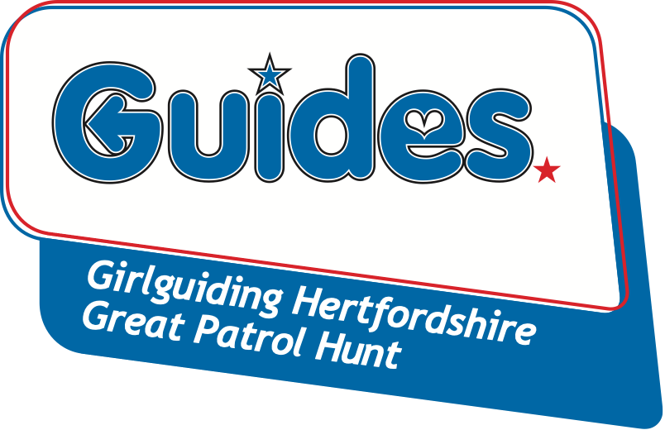

Thank you for your interest in the Great Patrol Hunt annual competition to find the ‘Greatest Patrol’ in Hertfordshire.

We want to make the entry process as easy as possible. Please complete the entry form and send it with payment to the address below along with a completed separate Information & Consent form for each individual attending, you can download a prepared form from the GPH page of the Girlguiding Hertfordshire website.
Please note:
- Places will be allocated on a ‘first come, first served’ basis. Patrols must consist of 4-6 Guides, and should not include more than 10 different members throughout the three rounds.
- Members must be 10-15 years old and be a member of a Guide Unit for each round they compete in.
- Teams need not be regular weekly Patrols, but they must choose a unique name for themselves in order to enter.
Great Patrol Hunt - Round 2
Saturday 26th March 2022
At Nicholas Breakspear Catholic School,
Colney Heath Lane, St Albans, AL4 0TT
- To be eligible for Round 3, a patrol and at least two of its participants must have competed in one of the previous rounds.

PATROL NAME: |  | UNIT NAME:
 | Participants Full Name | Your GG Registration No.  (ask your Leader) | £  (£5 per head)
PL
2
3
4
5
6
 |  | TOTAL | £

To be completed by your unit Guide Leader only (where appropriate please PRINT)
LEADER’S NAME:
LEADER’S SIGNATURE OF CONSENT:
LEADER’S EMAIL ADDRESS:
This email address will be kept on file and used to send you information relating to GPH and other events
TELEPHONE:

Cheques are made payable to ‘Herts Guides GPH’. Please post your completed Entry Form, payment and an Information & Consent form for each competitor to Jean Banks, 2 Rucklers Lane, Kings Langley WD4 8AU before the closing date Friday 4th March 2022 (LATE ENTRIES WILL NOT BE ACCEPTED).

On acceptance of your entry, patrol instructions are emailed to the Unit Leader after the closing date.

All patrols should make a unique patrol badge that clearly displays their patrol name and the patrol member’s name.

Competitors must wear their guide uniform top with their badge clearly displayed.

