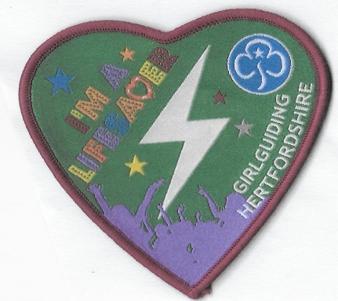
ORDER FORM
I’m a Lifesaver Badges

Your Unit and section
…………………………………………………………………………………………………………………
name and address for postage……………………………………………………………………………………………………..
.......................................................................................................................

Leaders email ……………………………………………………………………………………………

Number of badges at £1 each…………………………………… = £…………:………

Postage 1-10 badges @£1 …………………………………………. = £ ………:………

Postage of 10 plus badges @ £2.50 …………………… = £…………:………

Total = £………:…………
Pay 1st Aid Fundraising
To order email verity.guides@gmail.com .
Bank transfer 38360960 sort 30-96-26 / 46 Loom lane Radlett WD7 8PA
Your Feedback on badge and how the skills were shared appreciated
Many thanks for encouraging young members to learn simple skills that can save lives plus making a difference by sharing their skills
Monies raised will be put towards buying and maintaining community defibrillators and training.

