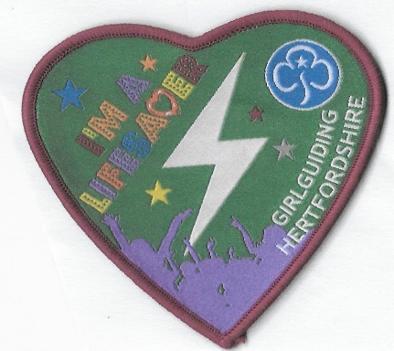
I’m a LIFESAVER badge
Aim
To encourage everyone to learn 1st Aid.
To spread the skills to parents and beyond.
To raise awareness of how essential the actions of those first at the scene are.
Ask for someone to visit and run a first aid evening at your unit meeting, or leaders with 1st response can do this themselves, Leaders can usually borrow mannequins for demonstration or ask parents with skills. There is a box of Mannequins at Hertfordshire County office or ask 1st Response trainers
Use apps and video clips to aid learning e.g. Red Cross, St John’s Ambulance, British Heart Foundation , resuscitation council.

Challenge: ALL Sections
1.Act out dramatic first aid scenes demonstrating simple lifesaving skills
2.Show your parents and family your new skills, teach them how to be a lifesaver.
Use on-line learning as below.
Rainbows: DRABC (the primary Survey) and the recovery position. Who to call when.
See Skills builders Level 2, these good for all levels
Brownies : as above plus major bleeding and choking
( without using force show how you would help a pretend choking casualty)
Guides and Rangers: as above plus CPR and Defibrillator (AED) use.
Check if your school has an AED and where it its kept. If not perhaps start fundraising for one with the school
Where is the nearest one to your home that is available to use 24/7 ?
DO NOT do chest compressions or rescue breaths on a pretend casualty.
I suggest using 2 cushions on the floor to show compressions. Improvise for AED pads after looking at online AED use , use large post it notes /paper cut outs.
Rangers and adults open this free interactive video from the resuscitation council. Guides please have a parent with you as it is very realistic.
https://life-saver.org.uk/interactive?id=harry
https://www.resus.org.uk/public-resource/how-we-save-lives/lifesaver-learning

Learning materials

Red Cross Apps Primary Survey, recovery Position, CPR , Choking, Major Bleeding. https://www.redcross.org.uk/first-aid/first-aid-apps

Recovery Position https://www.nhs.uk/conditions/first-aid/recovery-position/

CPR https://www.bhf.org.uk/how-you-can-help/how-to-save-a-life/how-to-do-cpr#cprvid
https://www.youtube.com/watch?v=GmqXqwSV3bo#action=share
Cardiac Arrest https://www.bhf.org.uk/informationsupport/conditions/cardiac-arrest

Defibrillator https://www.youtube.com/watch?v=-NcbDHv8Wi4

ORDER FORM
I’m a Lifesaver Badges

Your Unit and section
…………………………………………………………………………………………………………………
name and address for postage……………………………………………………………………………………………………..
.......................................................................................................................

Leaders email ……………………………………………………………………………………………

Number of badges at £1 each…………………………………… = £…………:………

Postage 1-10 badges @£1 …………………………………………. = £ ………:………

Postage of 10 plus badges @ £2.50 …………………… = £…………:………

Total = £………:…………
Pay 1st Aid Fundraising
To order email verity.guides@gmail.com .
Bank transfer / postal address on request
Your Feedback on the badge and how the skills were shared appreciated
Many thanks for encouraging young members to learn simple skills that can save lives plus making a difference by sharing their skills Monies raised will be put towards buying and maintaining community defibrillators and training.

