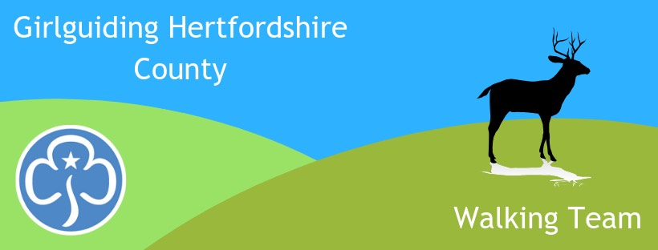
Girlguiding Hertfordshire
Follow us on Facebook for walking activities
www.facebook.com/hertsguideswalkingteam

Walking Team
Newsletter Feb 2022

Woohoo! Spring is here and Walking Team activities are starting to happen. The Bronze/Silver DofE training weekend was over subscribed and successful, so expeditions are now being planned and will happen ‘properly’ this year.

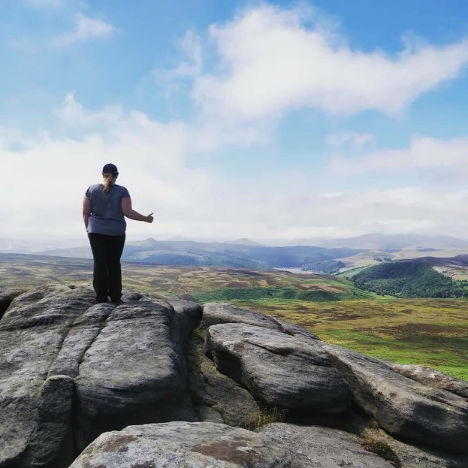
Mountain Experience is another fun weekend ahead for Rangers, in the Peak District in July. Please share the flyer with your girls which can be found on the website here. We could have an adult group too. In the daytime it’s a chance to get up onto the edge of Kinder Scout or onto Bamford Moor to practice navigation skills and then on Saturday night its downtime – hot chocolate, games, chatting, face packs whatever, the choice is yours. We sleep indoors with showers and a hot cooked meal.

For adults, Rangers & Young Leaders the next social walk is Sat 5th March, in the Lea Valley. And for those adults who want more, a whole weekend away in the Black Mountains 18-20th March. There will be two guided level 2 walks on offer, of about 5-6 hours, under 600m. Last chance to book NOW.

Further details regarding the next Anglia social weekend 10-12 June in Shropshire are available here.

For younger ones we are offering a Sensory Safari for Rainbows & Brownies and Explore 3 for older Brownies & Guides. Both walking team activites are to be included in the County Outdoor Activity Day on 23rd April.

See below for details of these and other events. Do join us.

Alison Tuch, County Walking Adviser

Events Diary email walking@girlguidinghertfordshire.org.uk to book unless stated otherwise
5- 6 March – 16 hour Outdoor First Aid course. SOLD OUT – applications for reserve list only. For those needing a 16 hour first aid qualification in conjunction with other outdoor leadership qualifications eg: walking, DofE, climbing, cycling. Also useful for anyone wanting to learn a bit more than First Response. Based at Little Gaddesden (W Herts), but much of the course will be taught outside and all scenarios will be in Open Country. Course fee £130.
Saturday 5th March – Social Walk in Lea Valley, around the Sculpture Trail. Approx 2-4pm. For adults, Young Leaders & Rangers. Just ‘walk & talk’ or improve your map reading skills if you wish – please say if you want this when booking. No charge.
18-20 March – Adult Social Walking Weekend. Staying 20 mins from Sugar Loaf in the Black Mountains. Accommodation £40 pp, shared transport. Opportunity to blow the cobwebs away and lift the spirits in the low mountains. Two guided level 2 walks on offer and higher peaks there for those who want more adventure.
Saturday 23rd April - Sensory Safari for Rainbows & Brownies and Treasure Hunt (Explore 3) for older Brownies & Guides. Both walking team activites to be included in the County Outdoor Day. £15. More information on the County website events page.
29th April – 2nd May - Introduction to the Hills. FULLY BOOKED - A camping weekend of walking, climbing, caving & cycling for Herts Guides and Scouts, aged 11 – 13.

Sunday 8th May – Social walk from Bramfield. For adults, Young Leaders & Rangers. 10.30-12.30. Just ‘walk & talk’ or improve your map reading skills if you wish – please say if you want this when booking. No charge.
10-12 June - Anglia Region Adult Social Walking Weekend in Shropshire – low cost, shared transport. Moderate level walking (level 2). See Anglia Girlguiding events page. Social walking weekend 2022 | Girlguiding Anglia (girlguiding-anglia.org.uk)
Saturday 18th June – Afternoon - Social geocaching in central Herts. For adults, Young Leaders & Rangers. Training and advice available. Please say if you want training when booking. No charge.
8-10 July - Mountain Experience, at Glenbrook Guide Centre, Peak District. A hillwalking weekend for Rangers & Young Leaders wanting to learn map reading & navigation skills for their own adventures, for DofE, or so that they can enter the Hertfordshire Scouts Peak Assault competition in remote terrain. £70 to include minibus transport, warm indoor bunk bed accommodation and food.
26-31 Aug - Anglia Heads High. A hill/mountain weekend in Crainlarich, Scotland for adults. £17/night or £75 for 5 nights. Option to self cater or pay £10 per day. Own travel. Email Moira Ledbetter moiledie@yahoo.co.uk for more information / to book.

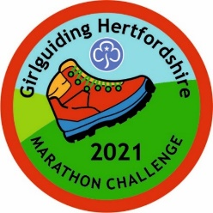
Final Note:
Have the Winter Olympics inspired you? Why not challenge your girls to walk another Marathon? Or to do their first one? We have plenty of badges in stock. Just walk, run or use a wheelchair to complete 42km over as many sessions as it takes. 2-3km a day soon adds up. You can carry on if you wish and earn the next 4 badges to make up the 5 Olympic rings. Check the website for details:
https://www.girlguidinghertfordshire.org.uk/get-involved/challenge-badges/#marathon

